**AMIs (Amazon Machine Images)**

Step 1- Make a instance, Go to action – Image and Template—Create image.

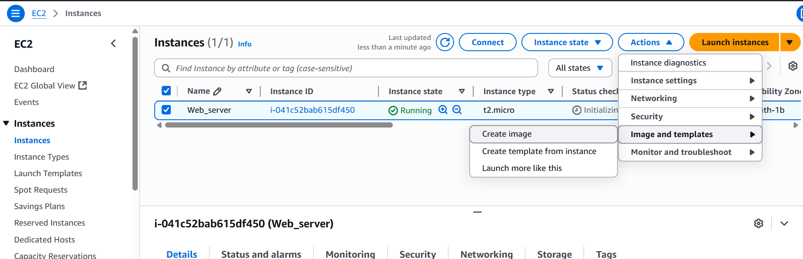

Step 2 – Now fill image name, some description if needed, if you want to restart your server then only check reboot instance box the create image.

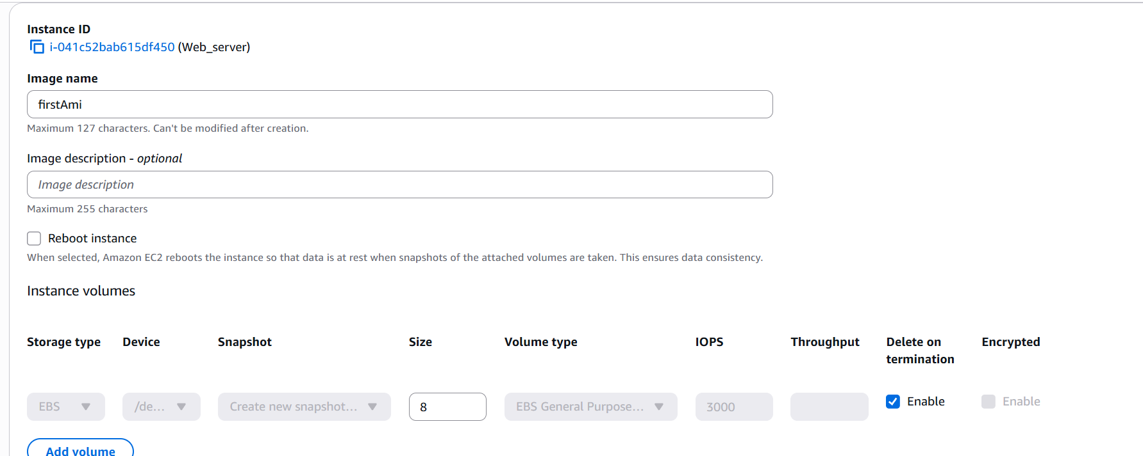

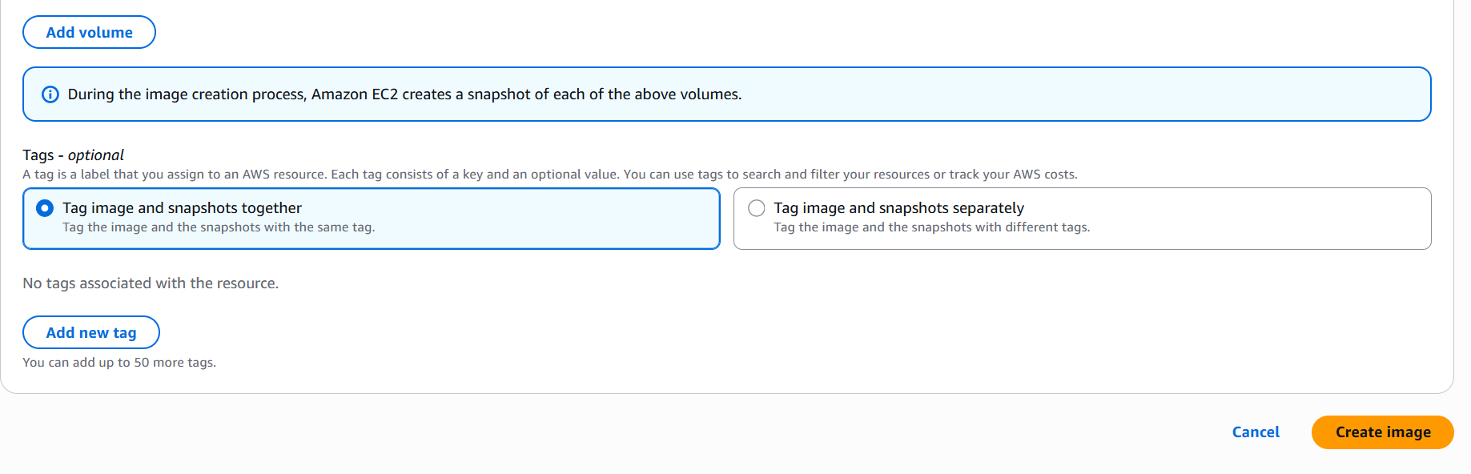

Step 3 – AMIs image is created, along with for our volume snapshot is created.

Note – AMIs takes backup of O.S and snapshot takes backup of volume.

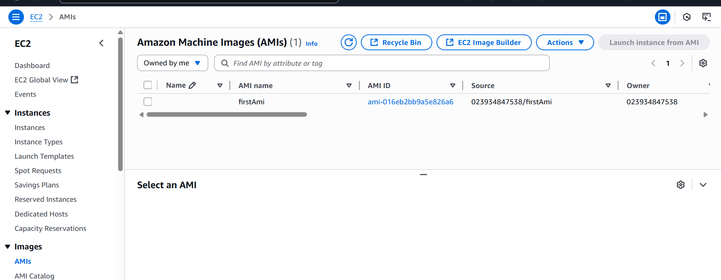

Step 4 – For some reason our instance is stops or terminated. Then we will create new instance from the existing AMIs image that is backup of our deleted instance.

Go to AMIs image – launch instance from AMI—fill details and launch.

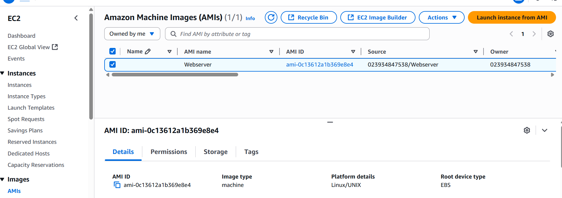

Step 5 – Here is new instance created. Note – now we have 2 volumes of from root instance and one from new instance. But the new instance do not take snapshot of volume only root instance take snapshot of volume. We can manually take snapshot in that situation.

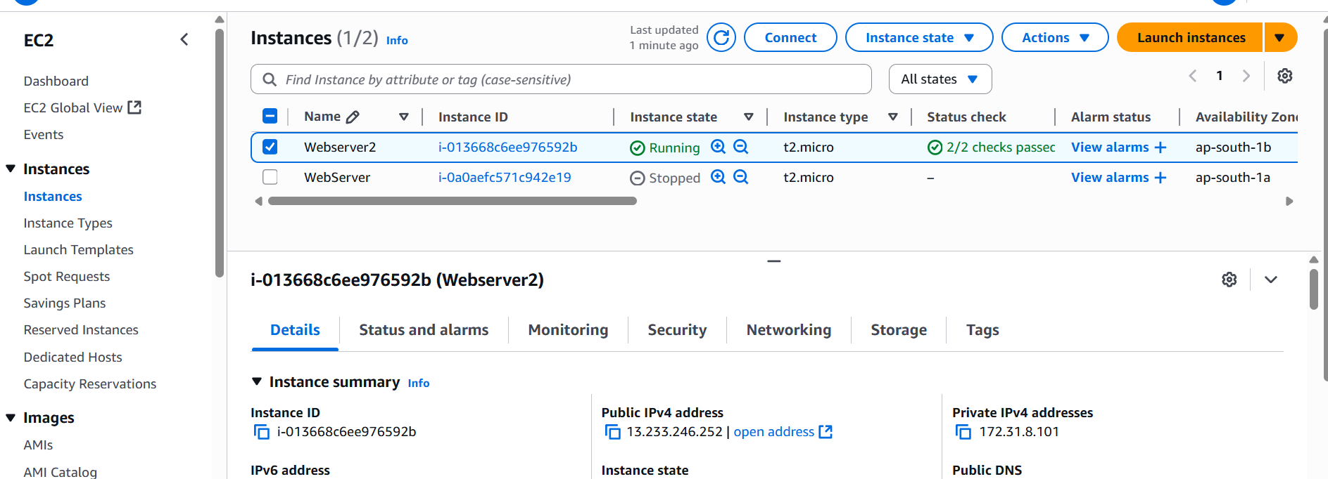

Step 6 – Successfully we connect using new instance.

